Week 5 – Day 1 Assignment - Read-pdf-extract-data

- Imported the ‘Extract Pdf -may Gen AI’ json
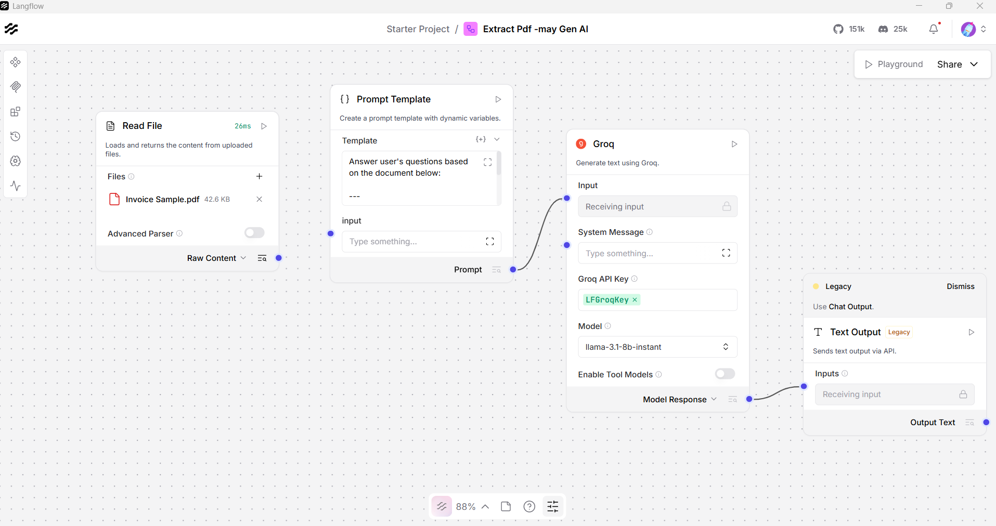

- Upload invoice pdf and extracted the following details
Invoice #:
Order #:
Invoice Date:
Due Date:
Total Due:

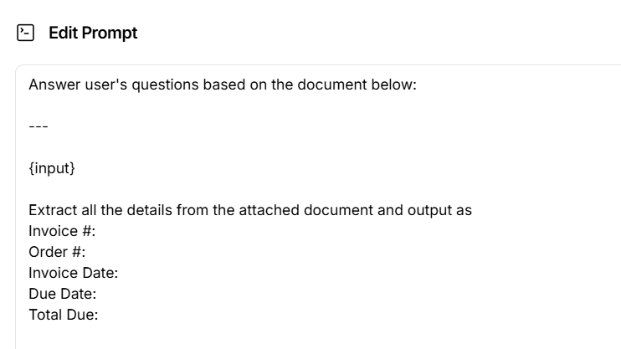
- Extracted the required details
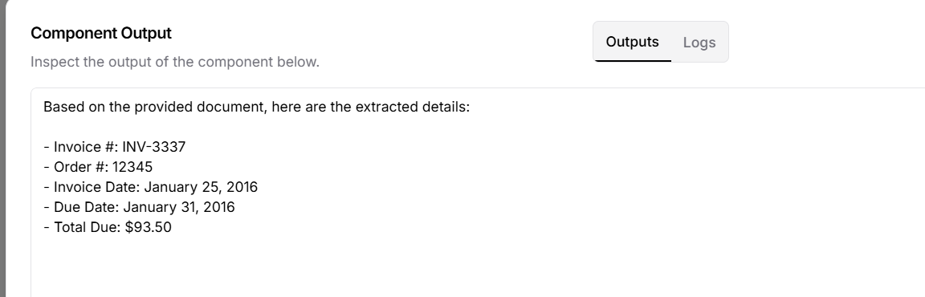

Also able to complete the user story review flow

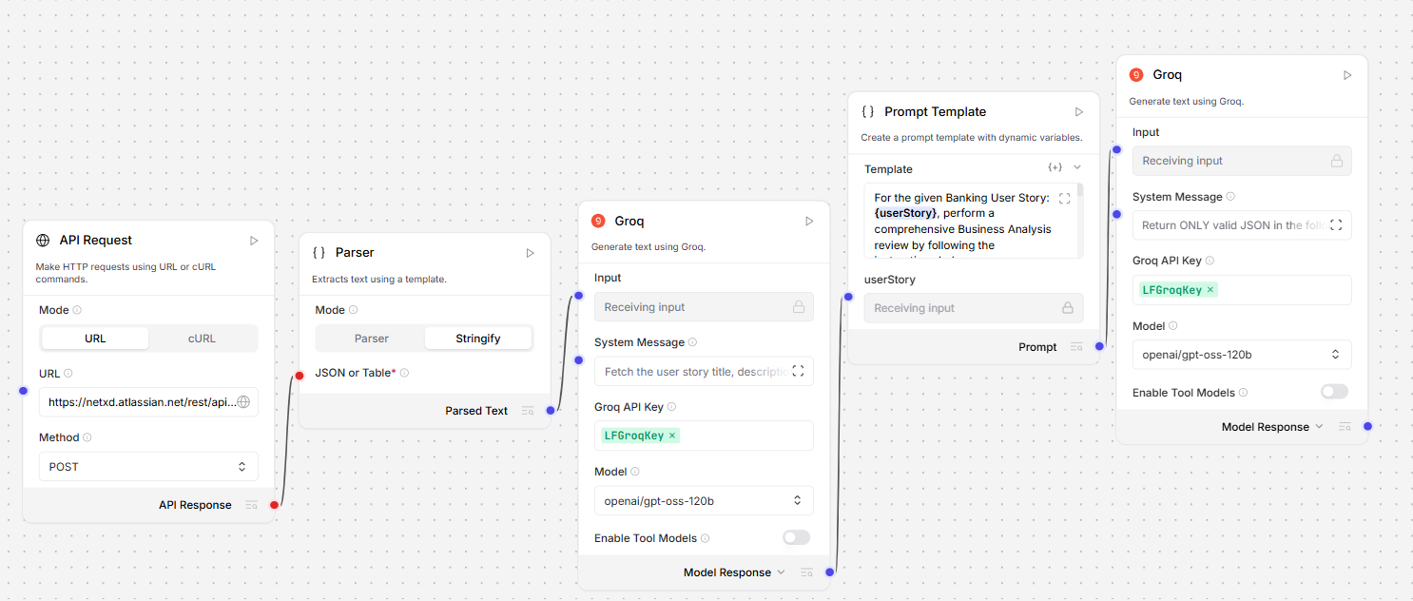
Return the review results in html format
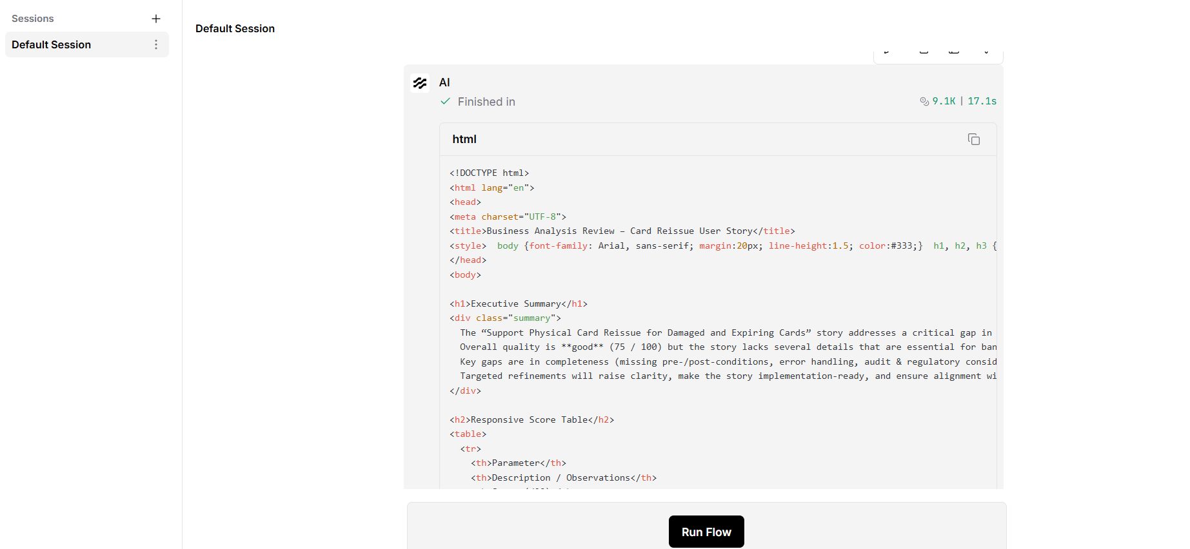
<!DOCTYPE html>
<html lang="en">
<head>
<meta charset="UTF-8">
<title>Business Analysis Review – Card Reissue User Story</title>
<style>
body {font-family: Arial, sans-serif; margin:20px; line-height:1.5; color:#333;}
h1, h2, h3 {color:#2F4F4F;}
.summary {background:#f0f8ff; padding:15px; border-left:5px solid #2F4F4F; margin-bottom:20px;}
table {width:100%; border-collapse:collapse; margin-bottom:20px;}
th, td {border:1px solid #ddd; padding:8px; text-align:left;}
th {background:#f2f2f2;}
.score {font-weight:bold; color:#fff; padding:3px 6px; border-radius:4px;}
.green {background:#28a745;}
.orange {background:#fd7e14;}
.red {background:#dc3545;}
.section {margin-bottom:25px;}
.recommendations ul {margin-left:20px;}
.revised {background:#fafafa; border:1px solid #ddd; padding:15px; font-family:"Courier New",Courier,monospace;}
</style>
</head>
<body>

<h1>Executive Summary</h1>
<div class="summary">
The “Support Physical Card Reissue for Damaged and Expiring Cards” story addresses a critical gap in the current card‑management flow.
Overall quality is **good** (75 / 100) but the story lacks several details that are essential for banking‑grade implementation, testing, and compliance.
Key gaps are in completeness (missing pre‑/post‑conditions, error handling, audit & regulatory considerations) and testability (insufficient negative & performance scenarios).
Targeted refinements will raise clarity, make the story implementation‑ready, and ensure alignment with PCI‑DSS, auditability, and operational resilience.
</div>

<h2>Responsive Score Table</h2>
<table>
<tr>
<th>Parameter</th>
<th>Description / Observations</th>
<th>Score (/20)</th>
</tr>
<tr>
<td>Clarity</td>
<td>
The story explains the need and high‑level flow, but it does not follow the classic “As a … I want … so that …” format, and some terms (e.g., “CARD_NOT_ACTIVATED status for the same account/card relationship”) are ambiguous.
Minor inconsistencies in wording make it harder for non‑technical stakeholders to grasp the intent quickly.
</td>
<td><span class="score orange">16</span></td>
</tr>
<tr>
<td>Completeness</td>
<td>
Business rules are listed, yet the story omits: <br>
• Explicit pre‑conditions & post‑conditions <br>
• Error/exception handling (e.g., JPOS failure, duplicate reissue) <br>
• Idempotency & retry semantics <br>
• Audit‑logging & regulatory (PCI‑DSS) requirements <br>
• Performance & availability expectations <br>
• Dependencies on versioned APIs or data‑model changes.
</td>
<td><span class="score orange">13</span></td>
</tr>
<tr>
<td>Business Value Alignment</td>
<td>
Strongly supports operational efficiency, customer experience, and risk reduction by avoiding unnecessary card closures.
Could be reinforced by linking to specific KPI improvements (e.g., reduction in “card‑reissue turnaround time” or “customer support tickets”).
</td>
<td><span class="score green">17</span></td>
</tr>
<tr>
<td>Testability</td>
<td>
Acceptance criteria give a solid base for positive tests, but negative, boundary, concurrency, and security test cases are not explicit. <br>
No guidance on mock data, test data setup, or expected audit‑log entries.
</td>
<td><span class="score orange">14</span></td>
</tr>
<tr>
<td>Technical Feasibility</td>
<td>
The integration points (Ledger → Bridge → JPOS) are identified and the removal of the unique‑card‑number constraint is noted. <br>
However, the story does not detail data‑model changes, impact on downstream settlement, or required changes to monitoring/alerting pipelines.
</td>
<td><span class="score orange">15</span></td>
</tr>
</table>

<h2>Overall Quality Score</h2>
<p><strong>75 / 100</strong></p>

<h2>Key Strengths</h2>
<ul>
<li>Clear business problem – current process forces a full card closure for damaged/expiring cards.</li>
<li>Well‑defined high‑level flow (FinTech → Ledger → Bridge → JPOS).</li>
<li>Alignment with operational efficiency and improved customer experience.</li>
<li>Recognition of the need to keep the original card active until the replacement is live.</li>
</ul>

<h2>Improvement Summary & Recommendations</h2>

<h3>1. Clarity (Score: 16)</h3>
<ul>
<li><strong>Issue:</strong> Story lacks the standard “As a … I want … so that …” narrative and contains ambiguous terminology.</li>
<li><strong>Recommendation:</strong> Rewrite the opening sentence in user‑story format and define all status codes in a glossary.</li>
</ul>

<h3>2. Completeness (Score: 13)</h3>
<ul>
<li><strong>Issue:</strong> Missing pre‑conditions, post‑conditions, error handling, audit, compliance, performance, and dependency details.</li>
<li><strong>Recommendation:</strong>
<ul>
<li>Add explicit pre‑conditions (e.g., original card status = ACTIVE, no pending “CARD_NOT_ACTIVATED” cards).</li>
<li>Define post‑conditions (new card ACTIVE, original card CLOSED, audit record created).</li>
<li>Specify error scenarios (JPOS timeout, token generation failure, duplicate request) and required rollback behavior.</li>
<li>State PCI‑DSS audit‑log requirements (who, when, what changed).</li>
<li>Include non‑functional expectations (≤2 s API response, 99.9 % availability).</li>
<li>Document dependencies on versioned Bridge & Ledger APIs.</li>
</ul>
</li>
</ul>

<h3>3. Business Value Alignment (Score: 17)</h3>
<ul>
<li><strong>Issue:</strong> Value is implied but not quantified.</li>
<li><strong>Recommendation:</strong> Add measurable outcomes (e.g., “reduce average card‑reissue processing time from 48

